**Intermediate SQL**

**Question 1**

**Explanation: Counts number of students per section. Then finds section with highest and lowest enrollment.**

SELECT MAX(enrollment) AS max_enrollment, MIN(enrollment) AS min_enrollment

FROM (

SELECT course_id, sec_id, semester, year, COUNT(*) AS enrollment

FROM takes

GROUP BY course_id, sec_id, semester, year

) AS section_enrollments;

**Question 2**

**Output: Returns section(s) that had the highest number of students.**

SELECT course_id, sec_id, semester, year, enrollment

FROM (

SELECT course_id, sec_id, semester, year, COUNT(*) AS enrollment

FROM takes

GROUP BY course_id, sec_id, semester, year

) AS section_enrollments

WHERE enrollment = (

SELECT MAX(enrollment)

FROM (

SELECT COUNT(*) AS enrollment

FROM takes

GROUP BY course_id, sec_id, semester, year

) AS enrollments

);

**OR**

SELECT

course_id, sec_id, semester, year, COUNT(*) AS enrollment

FROM takes

GROUP BY course_id, sec_id, semester, year

HAVING COUNT(*) = (

SELECT

MAX(enrollment)

FROM (

SELECT

course_id, sec_id, semester, year, COUNT(*) AS enrollment

FROM takes

GROUP BY course_id, sec_id, semester, year

) AS enrollments

);

**Question 3**

**Explanation: Joins takes with section to count students per section. LEFT JOIN ensures sections with zero students are included.**

**Using scalar subquery**

SELECT s.course_id, s.sec_id, s.semester, s.year,

(SELECT COUNT(*)

FROM takes t

WHERE t.course_id = s.course_id AND t.sec_id = s.sec_id

AND t.semester = s.semester AND t.year = s.year) AS enrollment

FROM section s;

**OR**

SELECT

s.course_id, s.sec_id, s.semester, s.year,

IFNULL((

SELECT COUNT(*)

FROM takes t

WHERE t.course_id = s.course_id

AND t.sec_id = s.sec_id

AND t.semester = s.semester

AND t.year = s.year

), 0) AS enrollment

FROM section s;

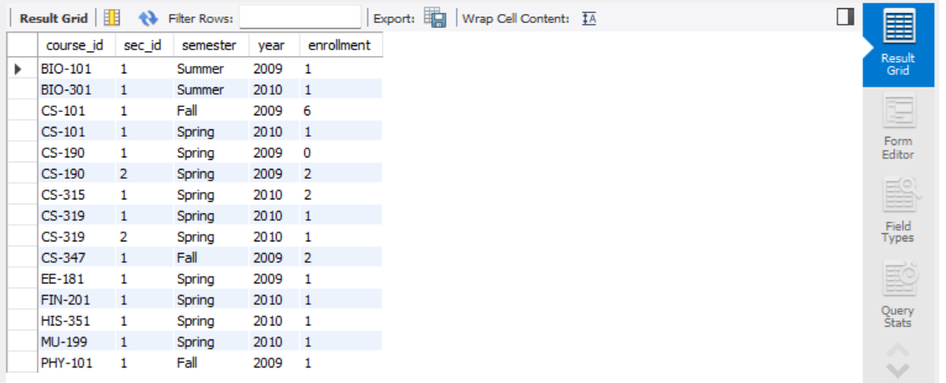

**Using left outer join with aggregation**

SELECT s.course_id, s.sec_id, s.semester, s.year,

COUNT(t.ID) AS enrollment

FROM section s

LEFT OUTER JOIN takes t

ON s.course_id = t.course_id AND s.sec_id = t.sec_id

AND s.semester = t.semester AND s.year = t.year

GROUP BY s.course_id, s.sec_id, s.semester, s.year;

**OR**

SELECT

s.course_id, s.sec_id, s.semester, s.year,

IFNULL(COUNT(t.ID), 0) AS enrollment

FROM section s

LEFT OUTER JOIN takes t

ON s.course_id = t.course_id

AND s.sec_id = t.sec_id

AND s.semester = t.semester

AND s.year = t.year

GROUP BY s.course_id, s.sec_id, s.semester, s.year;

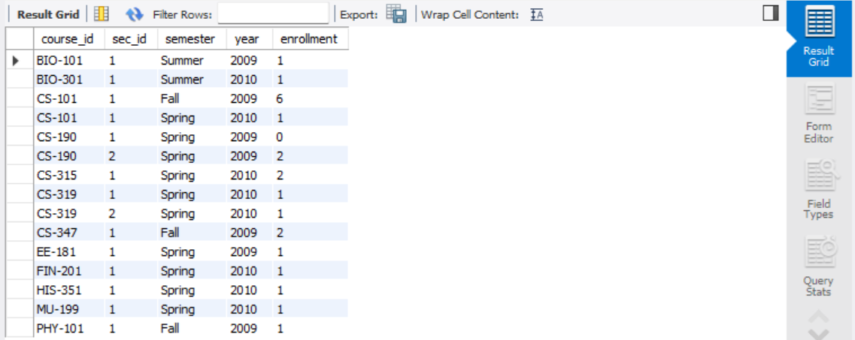

**Question 4**

**Explanation: Filters course_id that begins with 'CS-1' (e.g., CS-101, CS-102).**

SELECT * FROM course

WHERE course_id LIKE 'CS-1%';

**Question 5 (might need data)**

**Explanation: For each instructor, checks if there’s any 'CS-1%' course they haven’t taught. If not, include them.**

**Using NOT EXISTS… EXCEPT**

SELECT i.ID, i.name

FROM instructor i

WHERE NOT EXISTS (

SELECT c.course_id

FROM course c

WHERE c.course_id LIKE 'CS-1%'

EXCEPT

SELECT t.course_id

FROM teaches t

WHERE t.ID = i.ID

);

**OR**

SELECT i.ID, i.name

FROM instructor i

WHERE NOT EXISTS (

SELECT course_id

FROM course

WHERE course_id LIKE 'CS-1%'

EXCEPT

SELECT t.course_id

FROM teaches t

WHERE t.ID = i.ID

);

**Using matching counts**

SELECT i.ID, i.name

FROM instructor i, (

SELECT COUNT(DISTINCT course_id) AS total_cs1

FROM course

WHERE course_id LIKE 'CS-1%'

) AS needed

WHERE (

SELECT COUNT(DISTINCT t.course_id)

FROM teaches t

WHERE t.ID = i.ID AND t.course_id LIKE 'CS-1%'

) = needed.total_cs1;

**OR**

SELECT i.ID, i.name

FROM instructor i

JOIN teaches t ON i.ID = t.ID

WHERE t.course_id LIKE 'CS-1%'

GROUP BY i.ID, i.name

HAVING COUNT(DISTINCT t.course_id) = (

SELECT COUNT(*)

FROM course

WHERE course_id LIKE 'CS-1%'

);

**Question 6**

**Explanation: Adds instructors into student table. Prevents duplication using NOT IN.**

INSERT INTO student (ID, name, dept_name, tot_cred)

SELECT ID, name, dept_name, 0

FROM instructor;

**OR**

INSERT INTO student (ID, name, dept_name, tot_cred)

SELECT ID, name, dept_name, 0

FROM instructor

WHERE ID NOT IN (

SELECT ID FROM student

);

**Question 7**

**Explanation: Removes such students. Safe updates disabled to allow deletion with subquery.**SET SQL_SAFE_UPDATES = 0;

DELETE FROM student

WHERE tot_cred = 0 AND ID IN (SELECT ID FROM instructor);

SET SQL_SAFE_UPDATES = 1;

**Question 8**

**Explanation: Totals credits of passed courses and updates each student's tot_cred.**

UPDATE student s

SET tot_cred = (

SELECT SUM(c.credits)

FROM takes t

JOIN course c ON t.course_id = c.course_id

WHERE t.ID = s.ID

AND t.grade IS NOT NULL

AND t.grade != 'F'

);

**OR If you prefer to set those to 0 instead of NULL, wrap it with IFNULL(..., 0):**

UPDATE student s

SET tot_cred = IFNULL((

SELECT SUM(c.credits)

FROM takes t

JOIN course c ON t.course_id = c.course_id

WHERE t.ID = s.ID

AND t.grade IS NOT NULL

AND t.grade != 'F'

), 0);

**Question 9**

**Explanation: Each section taught adds 10,000 to salary.**

UPDATE instructor i

SET salary = (

SELECT COUNT(*) * 10000

FROM teaches t

WHERE t.ID = i.ID

);

**Advanced SQL**

**Question 1**

**Purpose: Creates a view of students who failed a course and never retook it and passed.**

**📤 Output: Rows from takes where the student got 'F' and no subsequent pass exists for the same course.**

CREATE VIEW UnoverriddenFails AS

SELECT * FROM takes t1

WHERE grade = 'F'

AND NOT EXISTS (

SELECT 1

FROM takes t2

WHERE t2.ID = t1.ID

AND t2.course_id = t1.course_id

AND t2.grade IS NOT NULL

AND t2.grade != 'F'

);

**Question 2 (might need data)**

**Purpose: Lists students who have failed at least 2 different courses and never passed them.**

**📤 Output: Entries from the UnoverriddenFails view filtered for those students.**

SELECT *

FROM UnoverriddenFails

WHERE ID IN (

SELECT ID

FROM UnoverriddenFails

GROUP BY ID

HAVING COUNT(*) >= 2

);

**Question 3**

**Output: Student ID, name, and CPI (Cumulative Performance Index). Students with no grades return NULL CPI (or use IFNULL(..., 0) if desired).**

CREATE TABLE grade_points (

grade VARCHAR(2) PRIMARY KEY,

point INT

);

INSERT INTO grade_points (grade, point) VALUES

('A', 10), ('A-', 9), ('B+', 8), ('B', 8),

('B-', 7), ('C+', 6), ('C', 6),

('C-', 5), ('D', 4), ('F', 0);

SELECT s.ID, s.name,

ROUND(SUM(gp.point * c.credits) / SUM(c.credits), 2) AS CPI

FROM student s

JOIN takes t ON s.ID = t.ID

JOIN course c ON t.course_id = c.course_id

JOIN grade_points gp ON t.grade = gp.grade

GROUP BY s.ID, s.name;

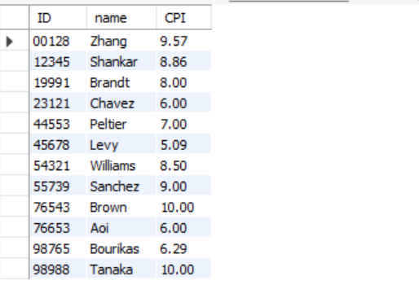

**Include All Students (Even if No Grades)- Use left outer join**

SELECT s.ID, s.name,

ROUND(SUM(gp.point * c.credits) / SUM(c.credits), 2) AS CPI

FROM student s

LEFT JOIN takes t ON s.ID = t.ID

LEFT JOIN course c ON t.course_id = c.course_id

LEFT JOIN grade_points gp ON t.grade = gp.grade

GROUP BY s.ID, s.name;

**Question 4 (might need data)**

**Purpose: Identifies course pairs scheduled in the same room, same time, same semester/year.**

**📤 Output: Conflicting course pairs (course1, course2) that overlap in schedule.**

WITH room_assignments AS (

SELECT course_id, sec_id, semester, year, building, room_number, time_slot_id

FROM section

)

SELECT

RA1.building, RA1.room_number, RA1.time_slot_id, RA1.semester, RA1.year,

RA1.course_id AS course1, RA2.course_id AS course2

FROM room_assignments RA1, room_assignments RA2

WHERE RA1.building = RA2.building

AND RA1.room_number = RA2.room_number

AND RA1.time_slot_id = RA2.time_slot_id

AND RA1.semester = RA2.semester

AND RA1.year = RA2.year

AND (RA1.course_id, RA1.sec_id) < (RA2.course_id, RA2.sec_id);

**Question 5**

**Purpose: Creates a simplified view showing basic instructor info.**

**📤 Output: View showing instructor ID, name, and department.**

CREATE VIEW faculty AS

SELECT ID, name, dept_name

FROM instructor;

**Question 6**

**Purpose: Restricts view to only Computer Science instructors. WITH CHECK OPTION ensures inserted/updated rows match the filter.**

**📤 Output: View of CS instructors only.**

CREATE VIEW CSinstructors AS

SELECT *

FROM instructor

WHERE dept_name = 'Comp. Sci.';

**OR (Enforce the Filter on Inserts)**

CREATE VIEW CSinstructors AS

SELECT * FROM instructor

WHERE dept_name = 'Comp. Sci.'

WITH CHECK OPTION;

**Question 7**

**Purpose: Demonstrates allowed and disallowed insertions into views.**

**📤 Output: First two insert; third fails due to WITH CHECK OPTION.**

INSERT INTO faculty (ID, name, dept_name)

VALUES ('99999', 'Ada Lovelace', 'Physics'); - **succeeds**

INSERT INTO CSinstructors (ID, name, dept_name, salary)

VALUES ('88888', 'Alan Turing', 'Comp. Sci.', 100000); - **succeds**

INSERT INTO CSinstructors (ID, name, dept_name, salary)

VALUES ('77777', 'Marie Curie', 'Physics', 95000); - **fails(with check option) bcs falls outside the dept_name requirement**

**Question 8**

**Purpose: Creates a new user and gives read-only access to the student table.**

**📤 Output: User created and can query student data.**

**Create user -** CREATE USER 'jane_doe'@'localhost' IDENTIFIED BY 'securepassword';

**Grant them permission -** GRANT SELECT ON university1.student TO 'jane_doe'@'localhost';

**Question 9**

**Purpose: Covers inter-user view sharing and access control.**

**📤 Output: Allows cross-user reading of views if proper GRANT is applied.**

1. **Grant SELECT to All Users on Your View**

GRANT SELECT ON university1.faculty TO '%'@'%';

**See if friend granted you**

SHOW GRANTS FOR CURRENT_USER;

**OR**

SHOW GRANTS FOR 'root'@'localhost';

1. **Select From a Friend’s View**

SELECT * FROM john_doe.faculty;

SELECT * FROM university1.faculty;

**Incase you don’t have permission (friend grants you) - GRANT SELECT ON university1.faculty TO 'your_username'@'localhost';**

GRANT SELECT ON university1.faculty TO 'root'@'localhost';